**Email: kaushal.singh@imarticus.com**

**Date: 21-12-2021**

Soft Skills

**What is required in the Industry?**

1. Basic Knowledge
2. Trainable (Knowledge, Skills, Flexibility)
3. True Professional/Human being (Punctual, Discipline, Sincere, Passionate)

**Skills Required?**

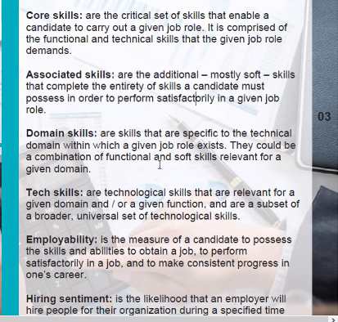

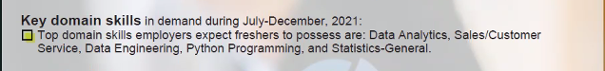

Analytical: Able to analyze problem and come up with many solutions and narrow down to optimal solution.

Growth Mindset: Looking into possibilities, able to take feedback/suggestions, learn from positives/negatives and grow as a personality.

**Vuca World**

1. Uncertainty/Unpredictable
2. Adaptable
3. Ambiguity
4. Complexity
5. Diversity

**SWOT Personal Analysis**

1. Strengths

Separate personal/professional problems, listener, understanding, perfection, adaptability, optimistic, opinionative.

1. Weaknesses

Anger/Irritation, Can’t say NO to help.

1. Opportunities

Stubbornness and hardworking not stay rest until getting the desired results (Data Engineer/Machine learning Engineer), Own place, Independence, Abroad).

1. Threats

Unable to complete work for not asking for help, not meeting standards.

**Time Chart**

Weekly goals, Time spent on a task/activity, Improvement area, Time saved.

**Stephen Covey’s Time Matrix**

|  |  |
| --- | --- |
| Important  (Urgent and Important)  Fire fighting situation, urgent/deadline task, do it now. | Not Important  (Urgent and Not Important)  Phone call that can be done later or attended by others, delegation of work |
| Not Urgent  (Not Urgent but Important)  Degree/certification which takes time, Important task which has release in months, planning needed. | Not Urgent and Not Important  Ignore it, Watching movies/series in Netflix. |

**Elevator Pitch**

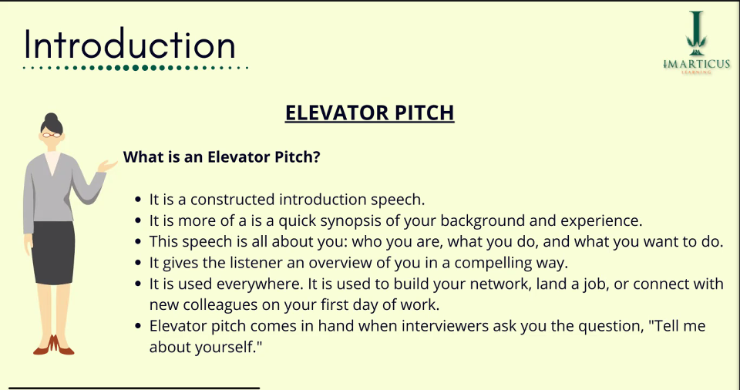

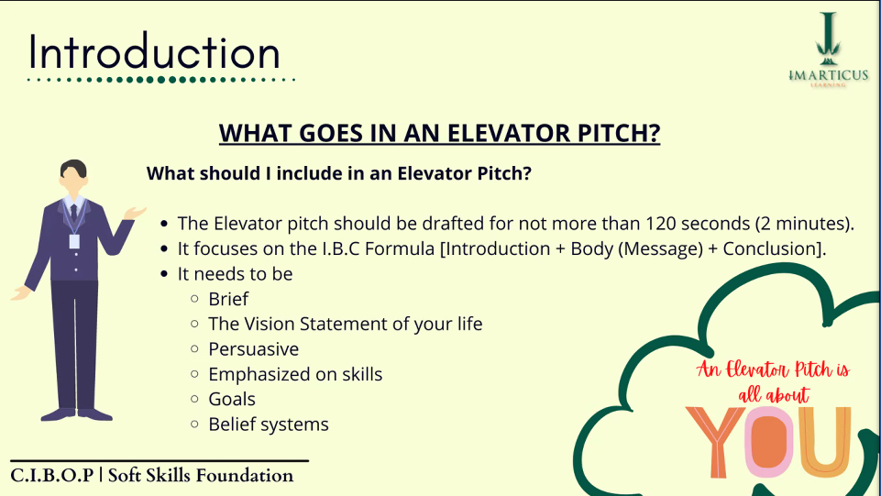

**Story, Examples, Strengths, Repeating skills, Unique selling trait/character (Dynamic, Hard work-Hustler, team player), Domain skill, 2-3 soft skills**

Introduction:

Name, City, work as a Full-stack Software Developer in a Startup company from more than 1 year.

Body:

Interest in AI and Machine Learning through projects.

Skills: JavaScript, Python, MongoDB and Relational database SQL.

Completed Bsc CS in the year 2019 and MSc CS Degree in 2021(Extracurricular), Upskilling by pursuing PGA program, Stubborn, professional, perfectionist, Flexible in positions, Helpful, Vocal (No hesitation in opinions), Work as both team leader and follower open to suggestions/opinions which makes me a vocal person. Way have of handling and managing team.

Conclusion:

My goal is to become either a machine learning engineer or a data engineer.

**Date: 25-01-2022**

**Cardinals of Communication**

**Importance of Storytelling:**

1. Humanizes or makes people empathetic
2. Explaining concepts using life experience
3. Makes people relate to you
4. Engage people

**Communication Phases:**

1) Listening:

(As long as you love me – Backstreet boys)

1st time listening (32 words, 15 non repetitive, 17 repetitive)

People say I'm crazy and that I am blind

Risking it all in a glance

I don’t care

Who you are?

Where you’re from?

What you did?

as long as you love me.

2nd time listening (35 words non repetitive)

**Note: Focus on important words**

Loneliness have been friend of mine

How you made me blind is still a mystery

Don’t care about the history

I can’t get you out of my head

The way you look into my eyes

2) Communication

3) Story telling

4) Body Language

**Obama Speech Video:**

Common ground

Empathy

Relatable to audience

Story

Unity One people

Body language using hands

Expressions – Eye contact all over

Hope

Sincerity - Honesty

Repetitive words (United States of America) – Antithesis process

**Lesson: Understanding client’s problems and giving the solution which we can give to solve their problems. Convincing that it is relatable to us by showing them the empathy and we understand them and their problems the best.**

**Speech Curation:**

**Data Analytics, Fundamental, Overfitting, Machine Learning, Backend, Regression, Correlation, Artificial Intelligence, Statistics, Outlier**

**Data Analytics** is a **Fundamental** part in any organization. **Data Analytics** is used to understand the pattern in the data stored on the **Backend** data source or various sites, and find some conclusions such as understanding patterns and trends in sales so that the organization can improve the future performance. Previously, basic concepts and formulas of **Statistics** was used for **Data Analytics.** With the growth of data, manual calculations became complex and difficult, so people started using tools like Excel for structured data. But as the diversity of data increased such as semi-structured & unstructured even Excel couldn’t such multi –dimensional data due to its complexity. To resolve such problems concepts of **Machine Learning** and **Artificial Intelligence** was introduced. Because of programming languages like Python and its libraries **Machine Learning** and **Artificial Intelligence** comes in handy for Predictions and Image processing. Some of the applications of **Machine Learning** and **Artificial Intelligence** are Stock price prediction, Recommendation engine, Face recognition, etc. In **Machine Learning,** one of the **Fundamental** technique is **Regression** which is used to find Relationship (increasing or decreasing)**. Regression** can be further classified as Linear **Regression,** Ridge **Regression,** Lasso **Regression,** etc. Out of these, Linear **Regression** where the linear term itself means data should fit in a straight line pattern when plotis most popular and commonly used model. Let us take an eg of property price prediction where firstly we assume that the data is normally distributed i.e most of the data is closer to the mean of the data, if not we use several standardization techniques to make it linear, we find and remove Outlier that can affect the mean which is generalizes data, find **Correlation** and remove dependent variables or features that are correlated to each other strongly and most important so the tern **Overfitting** creates a big distance between the predicted and target variable is resolved using Optimization Techniques. Once the data is clean we can fit the linear **Regression** model to predict the property price.

**Story Creation:**

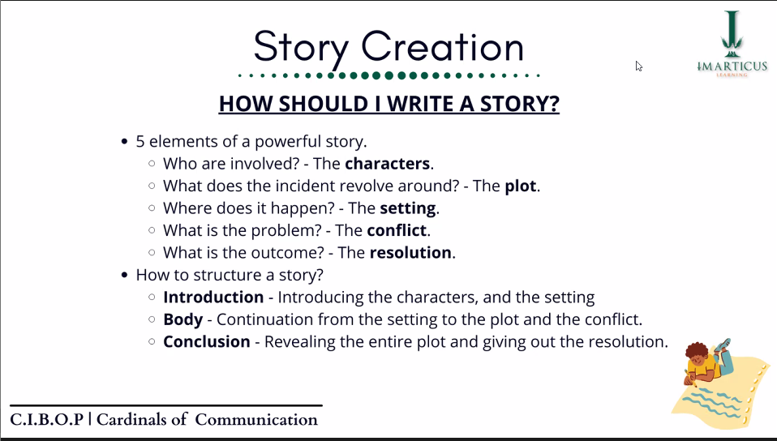

1. Origin of problem/conflict
2. Details (Mistakes/Advantage)
3. Results/Future

**Story Delivery:**

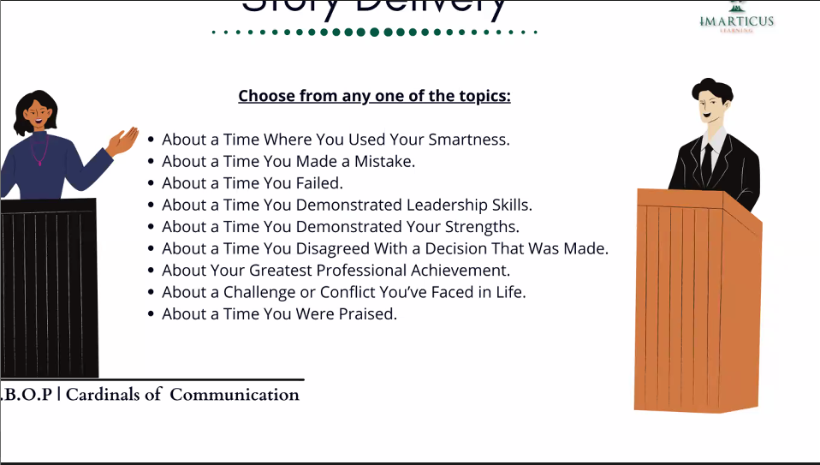

About a Challenge or conflict You’ve Face in Life

**Date: 08-02-2022**

**Honing Communication**

Adding humor, way of presenting by some hand movements and body languages, knowing when to say things it in a serious way, optimism, confidence, give examples, make it relatable.

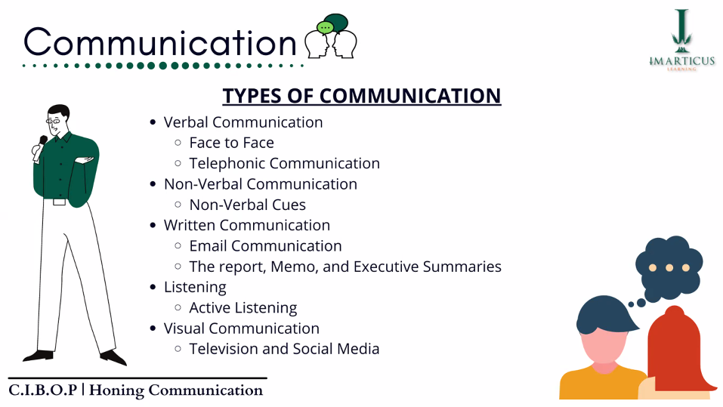

**Email to HR for extension of joining date:**

Subject: Extension of Joining Date

Dear/Hello PersonInConcern,

My name is Begum Zubeda. Around 2 months back I was filled with joy and excitement to be a part of such an amazing company when I received my dream job offer for the position of Machine Learning Engineer. The offer letter was signed and sent back in a few days after I received the mail. The joining date on the offer letter is in a week. But, due to some health issues I have been recommended by doctors to take rest for a week and it is difficult to join at this moment. It would be great if there is an extension for starting an amazing journey with your organization by a week at most.

I hope for the fast recovery and be the part of your team creating, innovating and helping each other to grow as a company.

Regards,

Begum Zubeda

Missing: Interview process compliments.

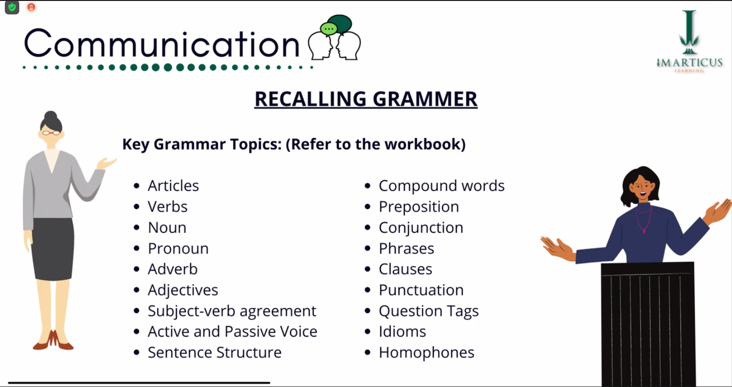

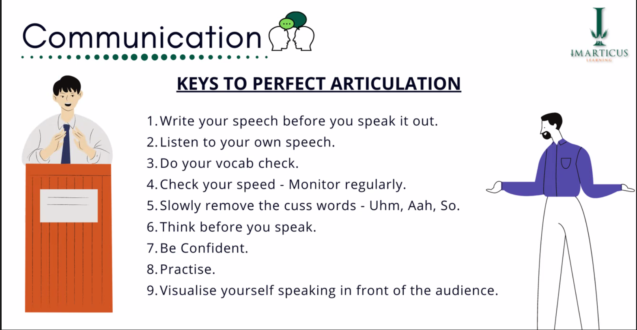

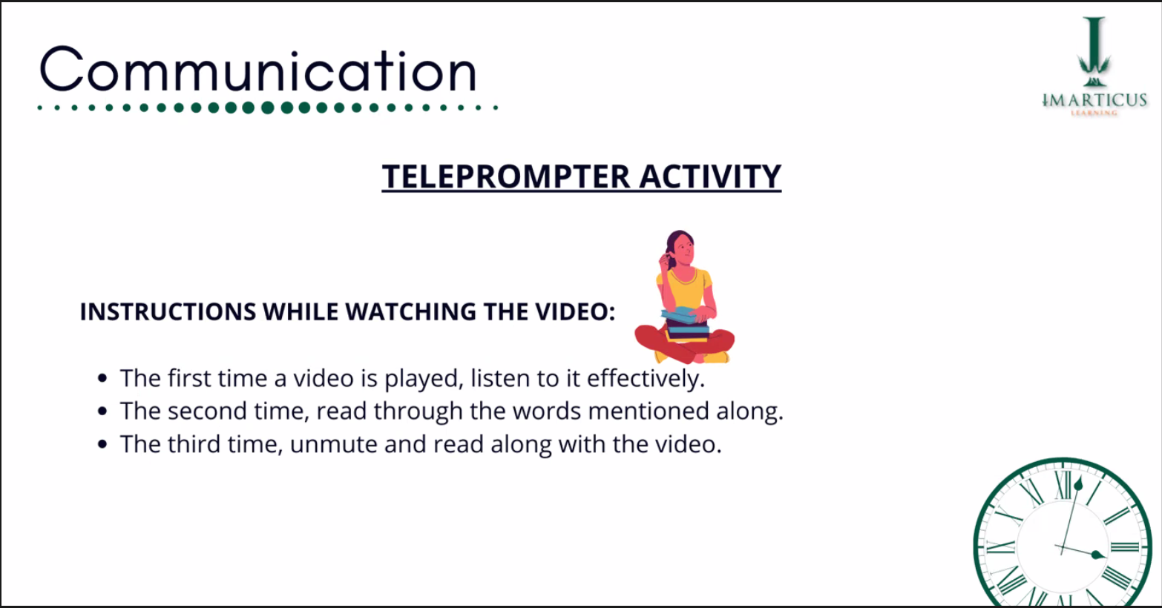

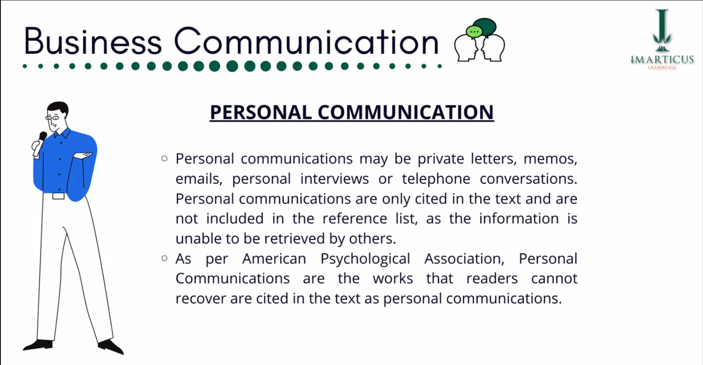

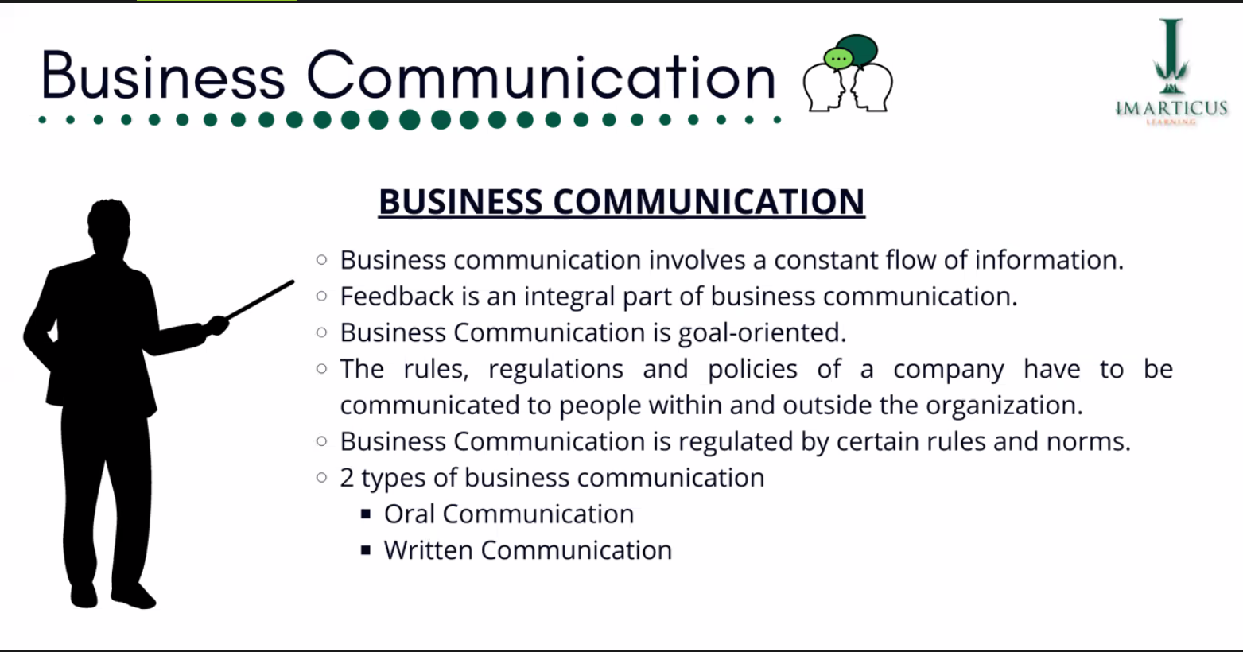

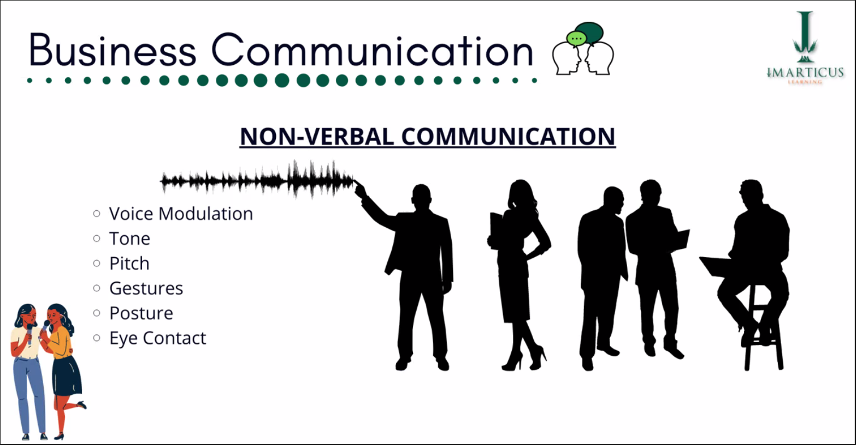

**Activity: LinkedIn Post Creation**

**Date: 05-04-2022**

**Resume Building:**

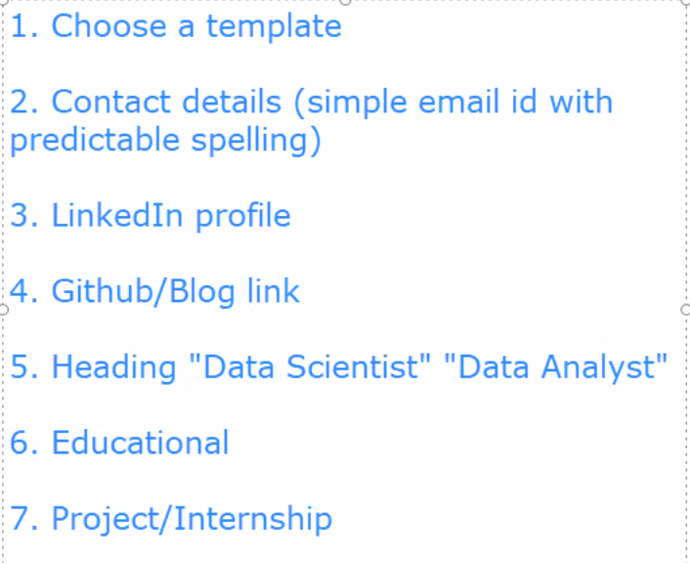

8. Soft skills

9. Achievements

**Resume template websites:**

